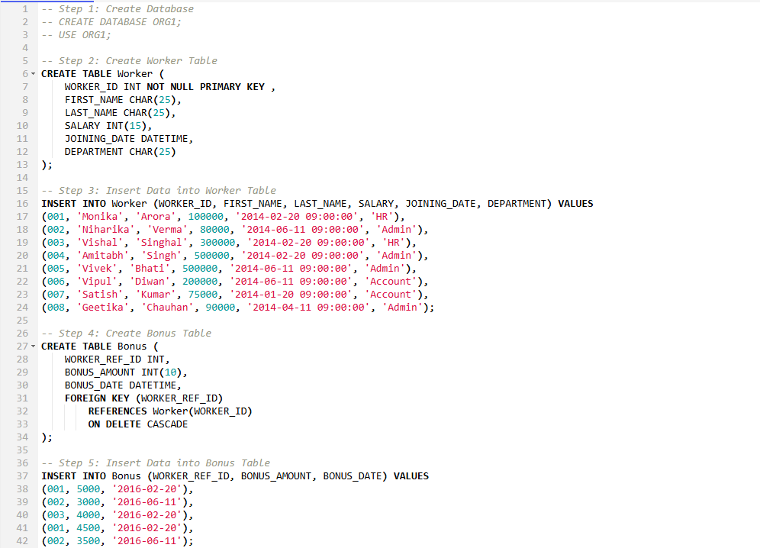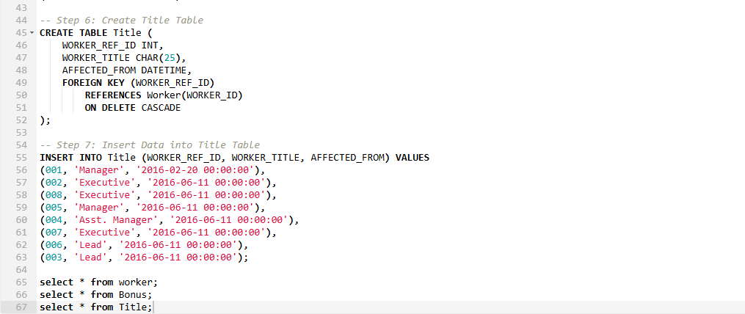SQL query questions



